JOB MARKET ANALYSIS

Name: VISHAL THAKUR https://github.com/VishalThakur10/Course
PROGRAM: DATA SCIENCE
DATA 039-007: DATA ARCHITECTURE
SUBMITTED TO: DR. JUNAID QAZI https://www.linkedin.com/in/jqazi
FEBRUARY 24, 2025

TABLE OF CONTENT

- PROJECT OVERVIEW
- PURPOSE AND GOALS
- KPI’S AND METRICES
- KEY QUESTIONS
- DATA MODEL
- DATA ITEGREATION
- DASHBOARD CREATION
- ESSENCE
- CONCLUSION

PROJECT OVERVIEW
This analysis examines current job market trends, focusing on salaries, skills, industries, and job positions. It will help us to identify different job locations, wages, work type and seniority level. A part from this, the dataset provides us accurate National and Provincial employment rates and job growth rates. The goal is to understand market patterns and support informed career and hiring decisions.
PURPOSE
Our main goals for this job market analysis are:
1: To analyze current employment and unemployment trends and to understand job market trend like to check the demand of various job roles and skills.
2: This dataset provides us wage growth and the satisfaction level of job.
3: Highlight the most sought-after technical and analytical skills in the job market.
4: It will identify new government job policies.
KPI & METRICS
1: Job demand by industry: It provide us availability of job opportunity in different location and identify which job needs which skills.
2: Average Salary by Job Position: To analyze salary status in different sector and position.
3: Top In-Demand Skills: It will give us data skills for example which skills are required for different job role.
4: Job opening by location: It shows the new job opportunities in cities and provinces.
5: Regional Employment Distribution: Comparison of employment rates across different provinces and major cities.
KEY QUESTIONS
1: Which industries have the highest number of remote and in-person jobs?
2: What was the overall employment growth in Canada over the past five years?
3: Which industry offers the highest minimum average salary?
4: Which industry have the highest job growth?
5: Which job position requires the highest skills?
DATA ITEGRATION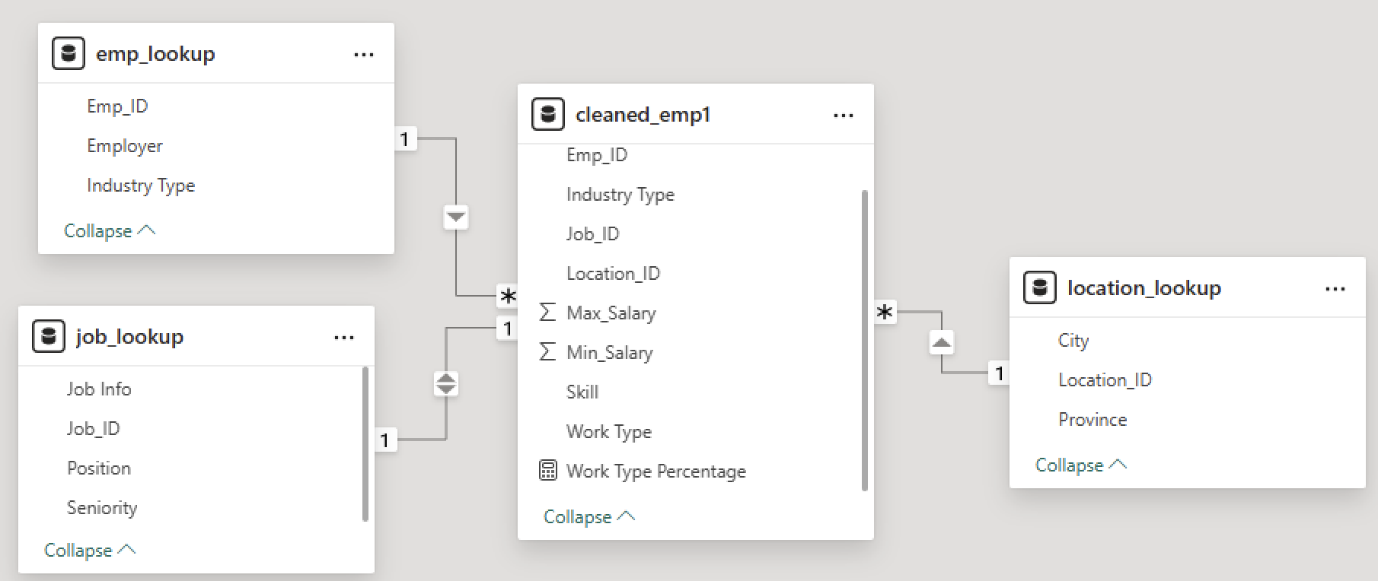
Figure 1
There are four tables in the project Emp, Job, Cleaned and Location. All these tables provide different knowledge like emp. table store all the information of employer for example, in which industry he/she works, along with this Job lookup and location table analyze job role, position, skills and locations.
DASHBOARD CREATION
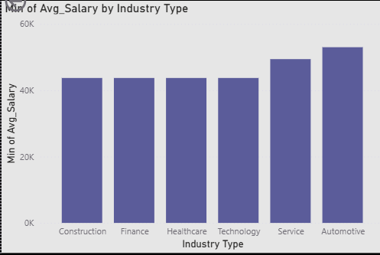
Figure 2

The given bar graph represents the average salary growth by different industries. The highest average salary is given by automative industry, followed by technology, healthcare, finance, and construction. The salary provided by last four sectors is more than 40 k.
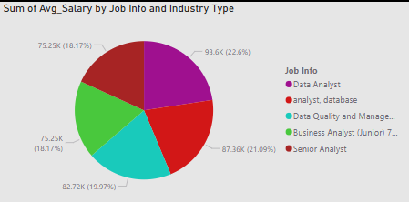
Figure 3
The given pie chart represents the average salary by different job roles in different sectors. The data analysist job has 93.6 k on annual basis which makes up 22.6%. Whereas, Database analysts earn 87.3 k annually that makes up 21.09% as shown in the pie chart. Then, business analysts are earning the least percentage that is 75. k making up 18.17 percentile.

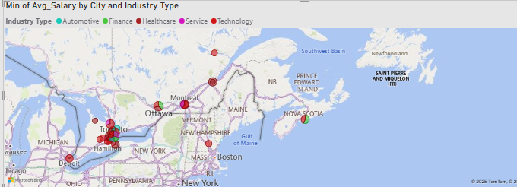
Figure 4
The given map shows the demand of different industries in various regions of the country. The industries of technology and healthcare has more demand in Greater Toronto Area and Ottawa while, Automotive and Finance has more opportunities in Nova Scotia.
ESSENCE
Industry Demand: The Automative and Technology has the highest demand for employees, followed by Healthcare and Finance.
Skillset Requirements: By analysing this report, the most demandable required skills are Data Analysis, Practical skills for construction and Programming.
CONCLUSION
By analysing a positive monument in job market, with sustained employment growth and declining unemployment. The job sector is highly dynamic, with greater demand for technology and healthcare profession. Moreover, geographical location plays a vital role in employment opportunities, big cities have more chances for better jobs than rural areas.

